

Patient Name___________________________ Social Security____-_____-____ Email___________________________
Address ________________________________City ___________________ State _______ Zip____________________ Age ___________Birth Date ________/______/____ Marital Status: M - S - D - W Number of Children______________
Home Phone # ( ) _______ - ______________________ Cell Phone # ( ) _______ - ________________________

Occupation________________________________ Work Phone # ( ) _______ - ____________ext._________
Employer _________________________________________________________________________________________
Employer Address _________________________________________________________________________________
Spouse’s Name ___________________________Occupation _______________________________________________
Whom may we thank for referring you? _______________________________________________________________
_________________________________________________________________________________________________
Purpose of this Appointment _________________________________________________________________________

What treatment have you already received for your condition? Medication Surgery

Chiropractic Care Physical Therapy None Other ____________________________________________
Have you been treated for any health condition by a physician in the last year? No Yes
Have you ever had Chiropractic Care before? No Yes -- Dr.’s Name_____________________________________

Are you taking medication? If so please list them__________________________________________________________ List surgical operations and years _____________________________________________________________________
Please indicate areas of pain:
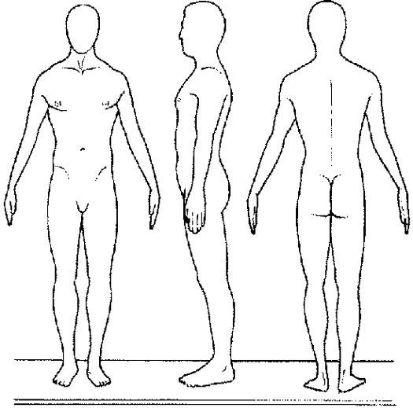

What functions are you unable to perform, or induce pain upon doing so? (example: sit, bend, walk, sleep, etc.)
- ___________________________________________3._______________________________________________________
- .__________________________________________ 4._______________________________________________________

List conditions you are interested in getting corrected in order of importance:
- ___________________________________________ 3._______________________________________________________
- ___________________________________________4.________________________________________________________

Women: Are you pregnant at this time? No Yes – Due date __________________________________________

Have you ever suffered from:
Dizziness Neck Pain Cancer High Blood Pressure Sinus trouble
Backaches Diabetes Headaches Arthritis Digestive disorders
Neuritis Nervousness Asthma Allergies Heart Trouble

If determined that your health could be improved, would you want to receive chiropractic care at this office? No Yes
IF YOUR CONDITION IS THE RESULT OF AN INJURY, PLEASE COMPLETE THIS SECTION:

Is your case: Workers Compensation No Fault Personal Injury

Date of injury:______________Time:______________Location:______________________________________________

Please describe how injury happened: __________________________________________________________________
_________________________________________________________________________________________________

Did you report your injury? No Yes – To whom? _____________________________________________________

Were you hospitalized? No Yes – Where? _________________________________________________________

By ambulance? No Yes Were X-rays taken? No Yes – By whom? ___________________________________

Date(s) of hospitalization_____________________ Medication(s) prescribed____________________________________
Are you presently working? No Yes – Dates of time lost from work _______________________________________
Have you been treated by any other chiropractor or physician for this injury? No Yes
If yes, Doctor’s name & specialty_______________________________________________________________________

COMMUNICATION CHANNELS:
To help us to better explain your Chiropractic condition and how we may be able to help you, please check the best answer :
1. I remember important things in my life by
what I see. what I hear. what I feel.
2. The primary reason I brush my teeth is to
avoid tooth decay and gum disease. make sure I have healthy teeth and gums.
3. When I make decisions I generally
gather facts and weigh the evidence. make the right choice instantly.
consult my friends and family . depend upon how I “feel” about it.

PLEASE LIST TOP THREE STRESSES IN EACH CATEGORY:
Physical stress (falls, accidents, work postures, etc.)
- __________________________________________________________________________________________
- __________________________________________________________________________________________
- __________________________________________________________________________________________
Bio – chemical stress (smoke, unhealthy food, missed meals, don’t drink enough water, drugs, etc.)
- __________________________________________________________________________________________
- __________________________________________________________________________________________
- __________________________________________________________________________________________
Psychological stress (work, relationships, finances, self- esteem. etc.)
- __________________________________________________________________________________________
- __________________________________________________________________________________________
- __________________________________________________________________________________________

INSURANCE INFORMATION:

Do you have Health Insurance? No Yes – If yes, please continue:

Insurance Co.______________________________ Address_________________________________

Group #___________________ID #_________________ Phone number ______________________
Are you covered by any additional insurance? No Yes – If yes, please continue:

Policy Holder’s Name_____________________________________________ Birth Date ___/___/___

Insurance Co.______________________________ Address_________________________________
Group #___________________ID #_________________ Phone number ______________________

Payment Acknowledgement (Please Sign) – I understand and agree that Health and Accident Insurance policies are an arrangement between insurance carrier and myself. I also understand that this office will prepare any forms and reports necessary to assist me in making collection from the insurance company and that any amount authorized to be paid directly to this office will be credited to my account on receipt. However, I clearly understand and agree that all services rendered to me are charged directly to me and that I am personally responsible for payment. I also understand that if I suspend or terminate my care and treatment, any fees for professional services rendered to me or my dependent will be immediately due and payable.

Patient’s signature __________________________________ Date __________________

Insured’s signature __________________________________ Date __________________
Parent, Spouse or Guardian Signature____________________ Date _________________

Acknowledgment of Notice of Privacy Practices

We keep a record of the health care services we provide you. You may ask to see and copy that record. You may also ask to correct that record. We will not disclose your record to others unless you direct us or unless the law authorizes or compels us to do so. You may see your records or get information about it by contacting Elmsford Chiropractic Health & Wellness Center.

Our Notice of Privacy Practices describes in more detail how your health information may be used and disclosed, and how you can access your information.

*You may refuse to sign this acknowledgment*
By my signature below I acknowledge receipt of the Notice of Privacy Practices

Patient or legally authorized individual signature Date Time

Printed name if signed on behalf of patient Relationship

For office use only

We attempted to obtain written acknowledgment of receipt of our Notice of Privacy Practices, but acknowledgment could not be obtained because:
- Individual refused to signature
- Communication barriers prohibited obtaining acknowledgment
- An emergency situation prevented us from obtaining acknowledgment
- Other (Please Specify)

Additional Disclosure Authority

In addition to the allowable disclosures describe in the “Notice of Privacy Practices,” I hereby specifically authorize disclosure of my protected health care information to the person indicated below.

Any member of my immediate family: Yes___ No___

Spouse Only: Yes___ No___

Other (Please Specify) Yes___ No___

Signature: ___________________________________

Relationship to Patient: _________________________

